MINI PROJECT

**EMBEDDED C PROJECT**

## TITLE

DENSITY BASED TRAFFIC LIGHT SYSTEM

## SUBMITTED BY

Manish Rude

## DATE

APRIL.2022

**ABSTRACT**

Nowadays, controlling the traffic becomes major issue because of rapid increase in automobiles and also because of large time delays between traffic lights. So, in order to rectify this problem, we will go for density based traffic lights system. This article explains you how to control the traffic based on density.In this system, we will use IR sensors to measure the traffic density. We have to arrange one IR sensor for each road; these sensors always sense the traffic on that particular road. All these sensors are interfaced to the microcontroller. Based on these sensors, controller detects the traffic and controls the traffic system.In present, vehicular traffic is increasing throughout the world, especially in large urban areas. As the number of road user's increase constantly and current resources & infrastructures being limited; a smart traffic control will become a very important issue in the future. These needs have led to an ever increasing demand for an " intelligent " traffic control system. Therefore, optimization of traffic control to better accommodate this increasing demand is needed. Our project will demonstrate the optimization of traffic lights in a city using wireless sensors. Traffic light optimization is a tough problem. With multiple junctions, the complexity increases as the state of one light node influences the flow of traffic towards many other nodes. We proposed a traffic light controller that allows us to control and study different situations of traffic density. We sense the density of traffic using infra-red sensors. The key role behind the implementation of the " Traffic density based light control system " is to make use of an ATMEGA328 controller which performs processing of the real time data provided by the infra-red sensors, eventually controlling the traffic flow via the LED traffic lights.

**INTRODUCTION**

In the past, the researchers had gone through different types of technologies. Brief surveys of various solutions of the traffic congestion problems are presented. RFID & GSM is mentioned in the Road Traffic Congestion Monitoring and Measurement using Active RFID and GSM Technology. In this system active RFID tag, wireless coordinator, wireless router, GSM modems and monitoring station software are used. Here the wireless devices are mounted on either sides of the road and they collect the data from the active RFID tags. Through GSM, monitoring station will collect all the data and respond to the corresponding traffic signal. WSN was presented in the Priority Based Traffic Lights Controller Using Wireless Sensor Networks. In this a wireless sensor network is being used. To define the direction of any emergency vehicle, system uses a fuzzy logic and by collecting all the information the central monitoring system gives the corresponding appropriate response. The traffic lights that are in widespread use today do not do much intricate reasoning when deciding when to change the lights for the various road users waiting in different lanes. How long the signal stays green in one lane and red in another is most often determined by simple timing that is calculated when the crossing is designed. Even though today’s methods are robust and work well when the traffic load is distributed evenly across the lanes in the intersection, the systems are very inefficient because they are unable to handle various simple situations that arise throughout the day. Unnecessary waiting time in the signal can be avoided by determining in which side the green signal should be large during the traffic. This research is to design such a system which works on the traffic density and manages the signal lights according to the sensed density of the traffic through the infra-red Sensors. The timing of the signal lights will vary with respect to the varying density of the traffic, Hence Improving the light system and reducing the traffic congestion and other related problems .

**Problem Statement**

Traffic congestion is increasing on the road day- by- day. As a result of which, two main issues arises. The issues are no traffic, but still need to wait Heavy traffic jams. These problems occur due to fixed control on traffic. This research will aim to control the traffic according to the density, but in manner of programming which is already fixed in the system.

**Circuit Principal**

The main heart of this traffic system is microcontroller. IR sensors are connected to the PORT C (PC0, PC1, PC2, and PC3) of the microcontroller and traffic lights are connected to PORT B and PORT D. If there is a traffic on road then that particular sensor output becomes logic 0 otherwise logic 1. By receiving these IR sensor outputs, we have to write the program to control the traffic system.

If you receive logic 0 from any of these sensors, we have to give the green signal to that particular path and give red signal to all other paths. Here continuously we have to monitor the IR sensors to check for the traffic.

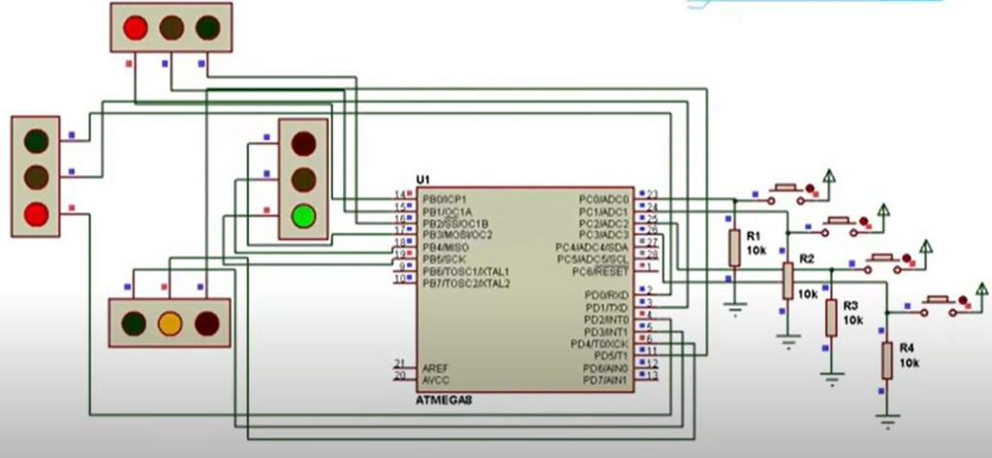

**Fig.Circuit Diagram**

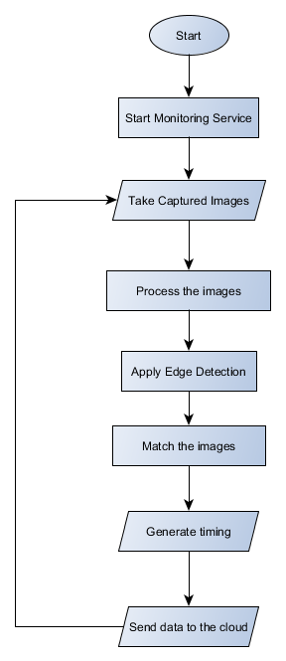

**FIG.FLOWCHART**

# **Basic Components OF A Density Based Traffic System**

## HARDWARE

### Circuit Components:

1. ATmega8 controller
2. PCB board
3. IR sensors -4
4. LED’s-12(4-red,4-green,4-yellow)
5. 12v Battery or adaptor
6. Serial cable
7. Connecting wires

# **SOFTWARE**

1. MICROCHIP STUDIO
2. VS CODE
3. SIMULIDE

### **ATmega 328** :-

[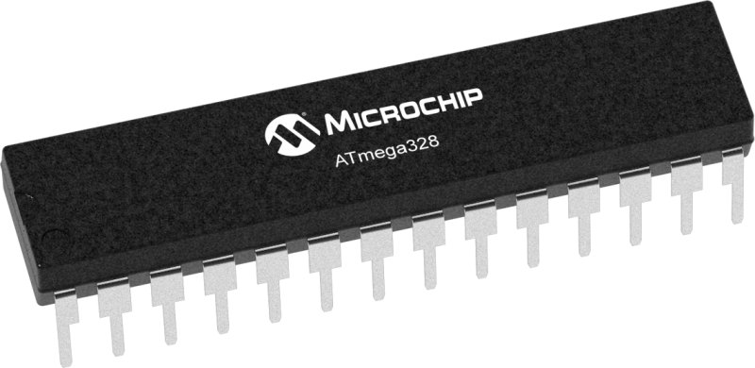](https://user-images.githubusercontent.com/101269445/164972991-e5818234-c3e5-46f8-97a2-e081de06cec3.jpg)

ATmega328 is commonly used in many projects and autonomous systems where a simple, low-powered, low-cost micro-controller is needed.The Atmel 8-bit AVR RISC-based microcontroller combines 32 KB ISP flash memory with read-while-write capabilities, 1 KB EEPROM, 2 KB SRAM, 23 general-purpose I/O lines, 32 general- purpose working registers, 3 flexible timer/counters with compare modes, internal and external interrupts, serial programmable USART, a byte-oriented 2-wire serial interface, SPI serial port, 6-channel 10-bit A/D converter (8 channels in TQFP and QFN/MLF packages), programmable watchdog timer with internal oscillator, and 5 software- selectable power-saving modes. The device operates between 1.8 and 5.5 volts. The device achieves throughput approaching 1 MIPS/MHz.

### **IR SENSOR :-**

[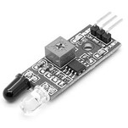](https://user-images.githubusercontent.com/101269445/164975344-1aeb4102-23f0-458b-a77e-f385bd2d742f.jpg)

An infrared sensor is an electronic device, that emits in order to sense some aspects of the surroundings. An IR sensor can measure the heat of an object as well as detects the motion. These types of sensors measure only infrared radiation, rather than emitting it that is called a passive IR sensor. Usually, in the infrared spectrum, all the objects radiate some form of thermal radiation. These types of radiations are invisible to our eyes, which can be detected by an infrared sensor. The emitter is simply an IR LED (Light Emitting Diode) and the detector is simply an IR photodiode that is sensitive to IR light of the same wavelength as that emitted by the IR LED. When IR light falls on the photodiode, the resistances and the output voltages will change in proportion to the magnitude of the IR light received.

### **LED :-**

[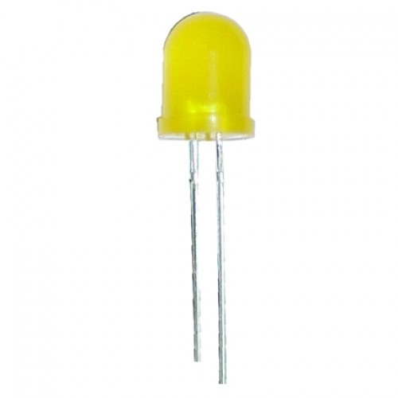](https://user-images.githubusercontent.com/101269445/164975525-3c0538a9-0d45-476f-91c1-1e8c7c8aed6c.jpg)

A light-emitting diode (LED) is a semiconductor device that emits light when an electric current flows through it. When current passes through an LED, the electrons recombine with holes emitting light in the process. LEDs allow the current to flow in the forward direction and blocks the current in the reverse direction.Light-emitting diodes are heavily doped p-n junctions. Based on the semiconductor material used and the amount of doping, an LED will emit a coloured light at a particular spectral wavelength when forward biased. As shown in the figure, an LED is encapsulated with a transparent cover so that emitted light can come out.

### **Density Based Traffic Light Control System Circuit Design:**

This circuit consists of 4 IR sensors, atmega8 microcontroller, 4 traffic lights.

IR transmitter looks like an LED. This IR transmitter always emits IR rays from it. The operating voltage of this IR transmitter is 2 to 3v. These IR (infra red) rays are invisible to the human eye. But we can view these IR rays through camera.

IR receiver receives IR rays that are transmitted by IR transmitter. Normally IR receiver has high resistance in order of mega ohms, when it is receiving IR rays the resistance is very low. The operating voltage of IR receiver also 2 to 3V.

We have to place these IR pair in such a way that when we place an obstacle in front of this IR pair, IR receiver should be able to receive the IR rays. When we give the power, the transmitted IR rays hit the object and reflect back to the IR receiver.

Instead of traffic lights, you can use LEDs (RED, GREEN, YELLOW). In normal traffic system, you have to glow the LEDs on time basis. If the traffic density is high on any particular path, then glows green LED of that particular path and glows the red LEDs for remaining paths.

In normal traffic system, we allow the traffic for a time delay of 1 minute for each path.

### **How to Operate Density based Traffic Signal System Circuit?**

* Connect 12V battery or adaptor to the development board.
* Switch on the supply.
* Burn the program to the ATmega8 microcontroller by keeping the programming switch sw2 in program mode.
* Connect four IR sensors to PORT C.
* Connect LEDs to PORT B and PORT D.
* Arrange all this LED’s same as like traffic lights.
* Arrange one IR sensor for each road.
* Now you can see the normal traffic system based on time basis.
* Now if you place any obstacle in front of any IR sensor, then the system allows the traffic of that particular path by glowing GREEN light.
* Finally, turn off the board power supply.

### **Limitations of this Circuit:**

* IR sensors sometimes may absorb normal light also. As a result, traffic system works in improper way.
* IR sensors work only for fewer distances.
* We have to arrange IR sensors in accurate manner otherwise they may not detect the traffic density.

**OUTPUT&SIMULATION**

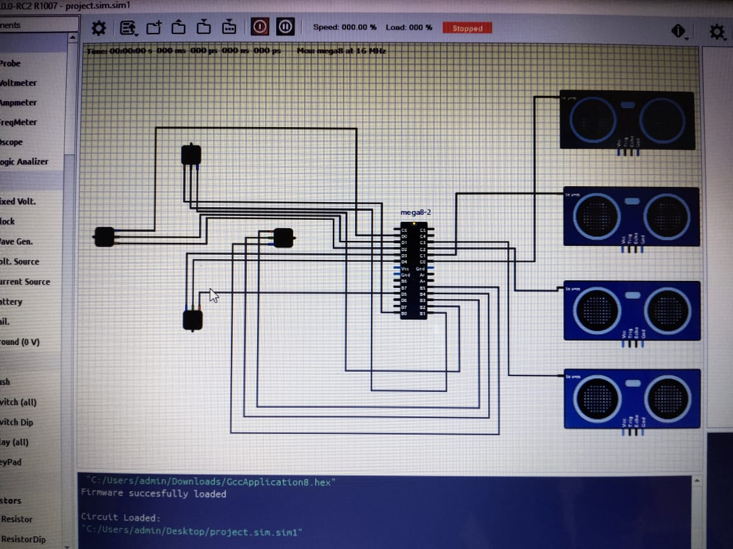

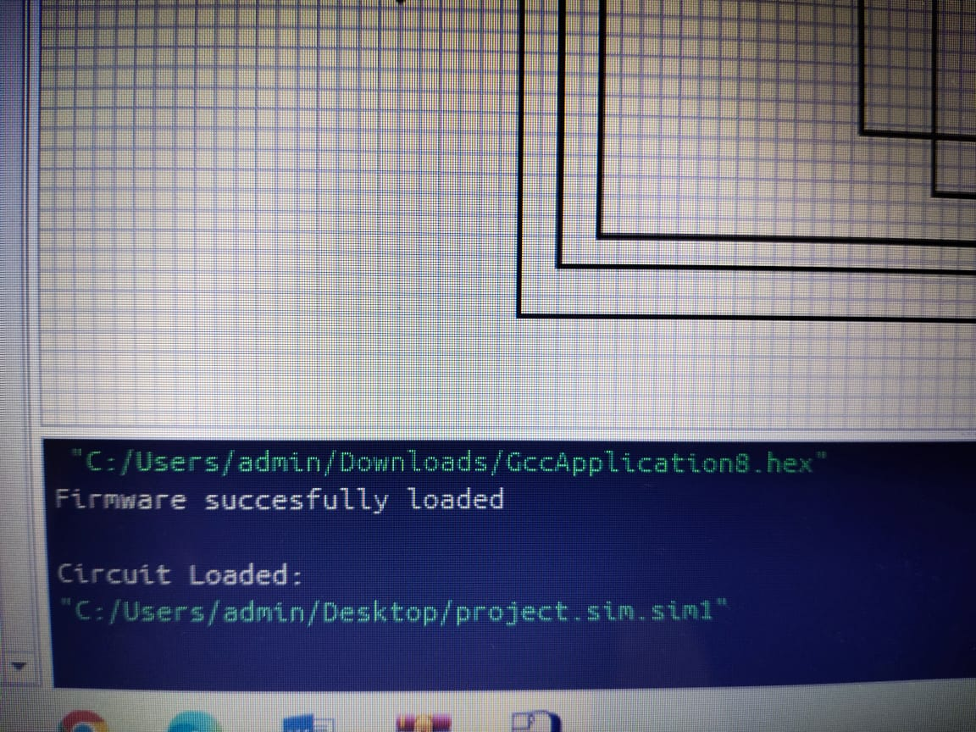

**Results &Analysis**

Results include the successful operation of the traffic control and monitoring system. The systemcontains twoIRtransmitter and IR receiver for traffic density measurement which are mounted on the either sides of roadsrespectively. The IR system gets activated whenever any vehicle passes on road between IR sensors. Whenonesensor will be ON at that time density will be less when two sensors will be ON at that traffic density is mediumwhen all 3 sensor will be ON at that time density will be high. Microcontroller controls the IR systemand countsnumber of vehicles passing on road. Based on different vehicles count, the microcontroller takes decisionandupdates the traffic light delays as a result.

* 1. Case 1 In this case the density is highest on the road 1 due to the presence of object on road 1.The higher density will causethe green light on road 1 will go green while red light will occur for road 2,road 3 & road 4
  2. Case 2 In this case density occurs at road 2 resulting in the green light to go green on road 2 and remaining road 1, road3&road 4 has red lights.
  3. Case 3 In this case density occurs at road 3 resulting in the green light to go green on road 3 and red light occurs for road1, road2 & road4 respectively
  4. Case 4 In this case density occurs at road 4 resulting in the green light to go green on road 4 and red light occurs for road1, road2& road3 respectively

**Conclusion**

In this research we have worked on Congestion problem for such special areas which have dense traffic density. The system works on traffic related problems such as traffic jam; un reasonable latency time of stoppage of vehicle, emergency vehicles or forcibly passing, etc can be solved. By using this system configuration we try to reduce the possibilities of traffic jams, caused by traffic lights. Number of passing vehicle in the fixed time slot on the road decide the density range of traffics and on the basis of vehicle density calculation, microcontroller decide the traffic